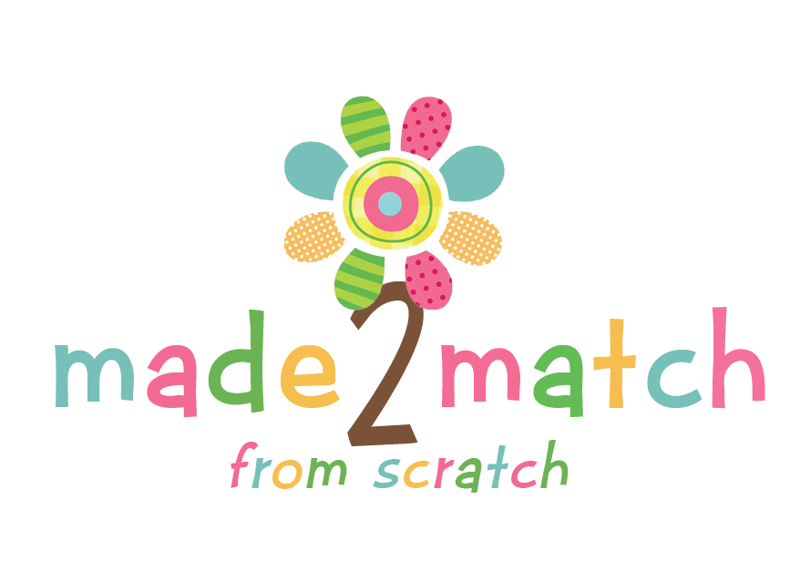
Online Bridal Shower: Registry Form
Bride’s Name:
Wedding Date:
Email Address:
Phone:
Mailing Address:
Product | Personalization | Color/Theme
Example: Bag Tag | “Newlyweds” | Blue/black
Please submit your completed form to Made2MatchFromScratch@gmail.com.
We will complete your registry and will send you a username/password.
This information will be used for your private Registry link to send to your shower guests.

